Steps to Design a Web App in Figma

===========================
Designing a web app in Figma usually follows this workflow:
- Research
- Wireframing
- UI Design
- Prototyping
- Developer Handoff

1. Define the Web App Idea
First decide:
- What problem the app solves
- Who will use it
- Main features

Example Web Apps
- Dashboard
- E-commerce site
- Learning platform
- Banking app
- Chat app
- Project management tool

2. Create a New Figma File

Steps
- Open:
  - Figma
- Click:
  - New Design File
Rename it:
- Project Dashboard UI
- E-commerce Web App
- etc.

3. Create Desktop Frames
Press:
- F → choose:
  - Desktop Frame
Common sizes:
- 1440 × 1024
- 1920 × 1080
Frames represent web pages.
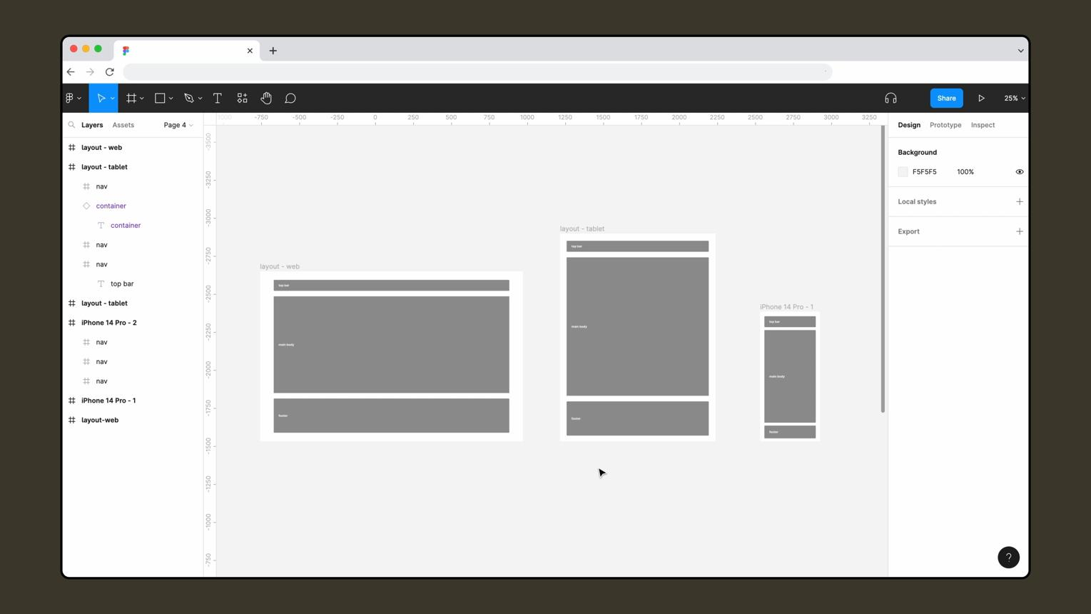



4. Plan the Layout Structure
Most web apps contain:

Common Sections
- Navigation bar
- Sidebar
- Main content
- Cards/widgets
- Footer
Example layout:
+--------------------------------+
| Navbar |
+------+-------------------------+
|Side | Main Dashboard Area |
|bar | Charts / Tables / Cards |
| | |
+------+-------------------------+

5. Create Wireframes
Wireframes are rough layouts.

Use:
- Gray boxes
- Placeholder text
- Basic shapes
Focus on:
- Structure
- User flow
- Content placement
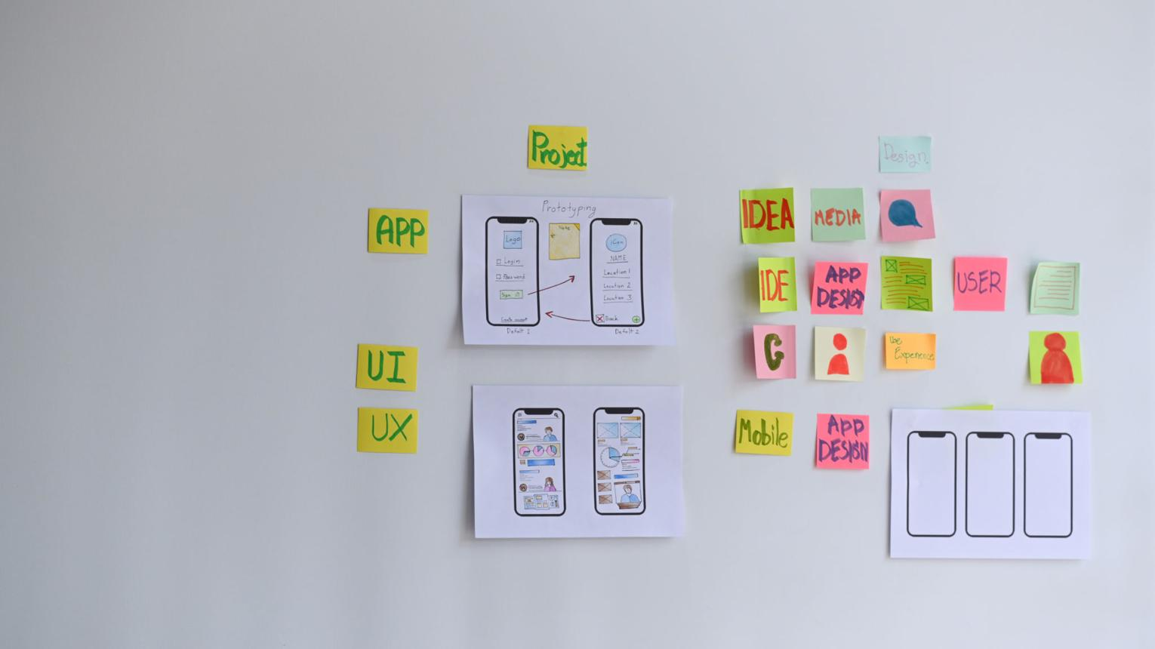
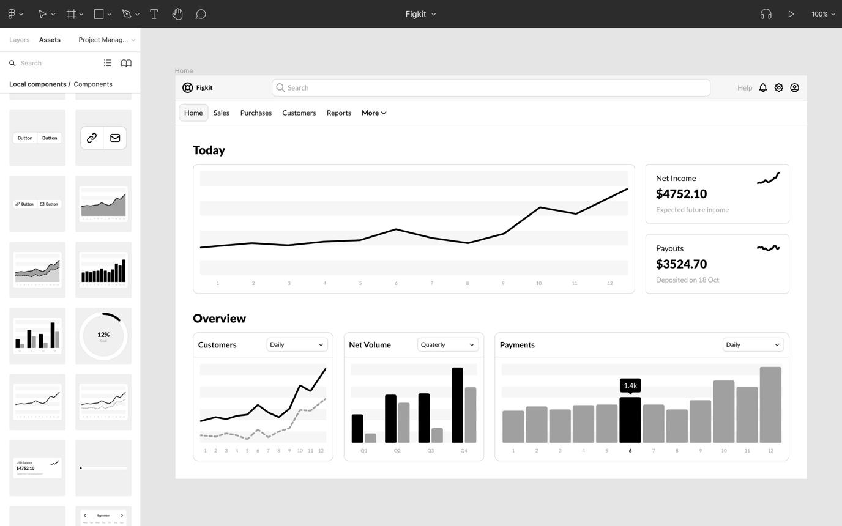
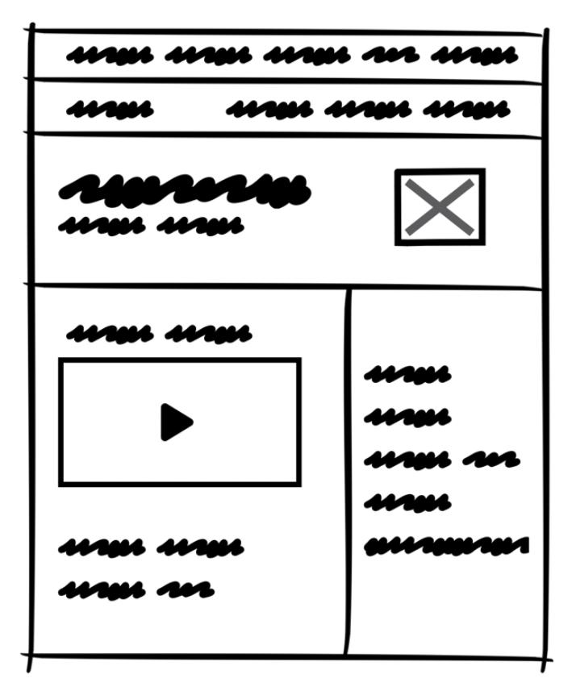

6. Design Navigation

Navbar
Include:
- Logo
- Search bar
- Notifications
- Profile menu

Sidebar
Include:
- Dashboard
- Settings
- Analytics
- Messages
Use:
- Icons
- Labels
- Hover states
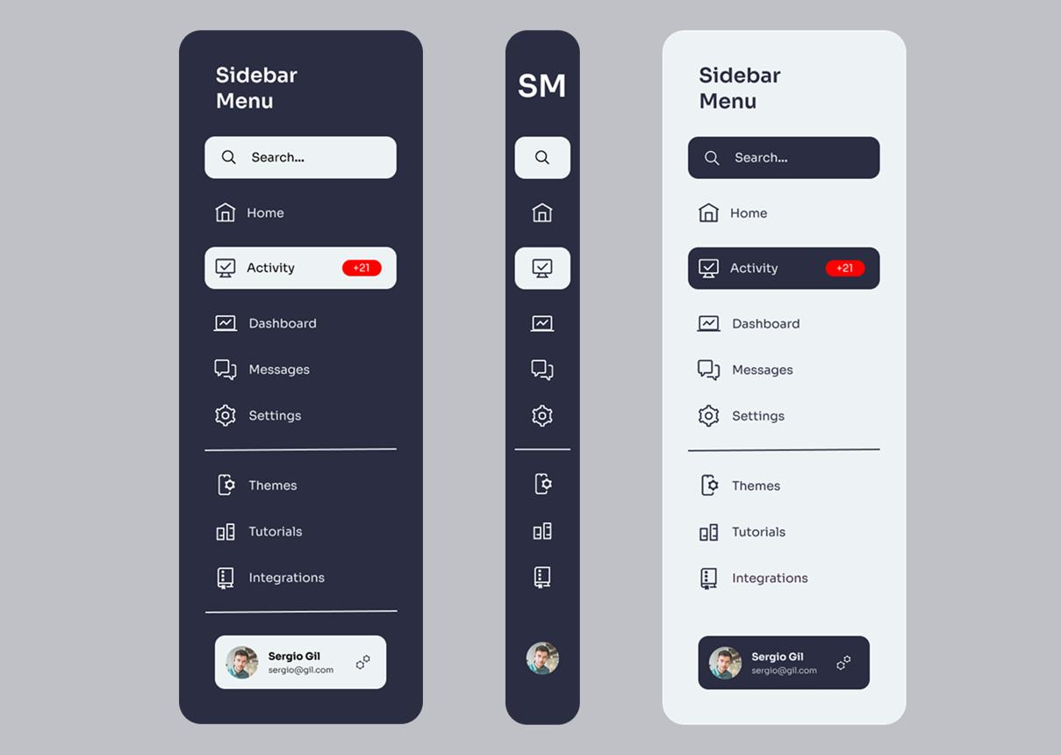
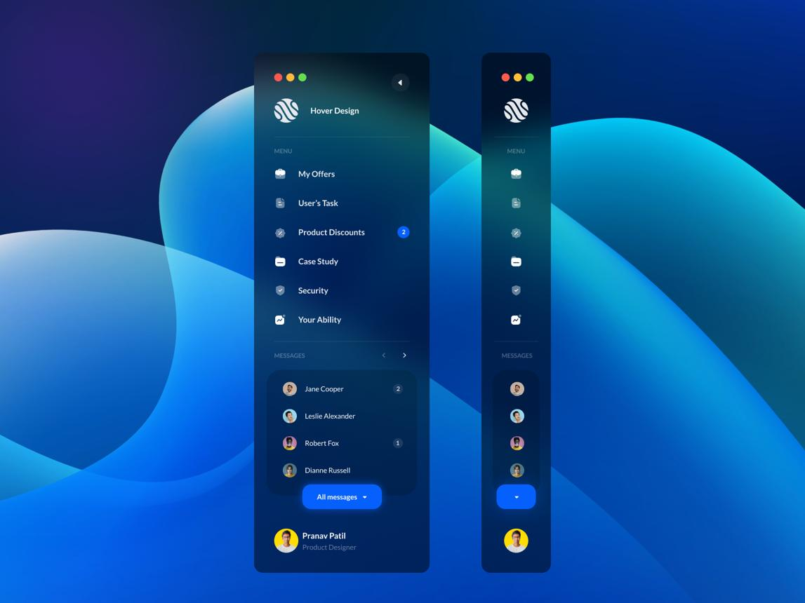
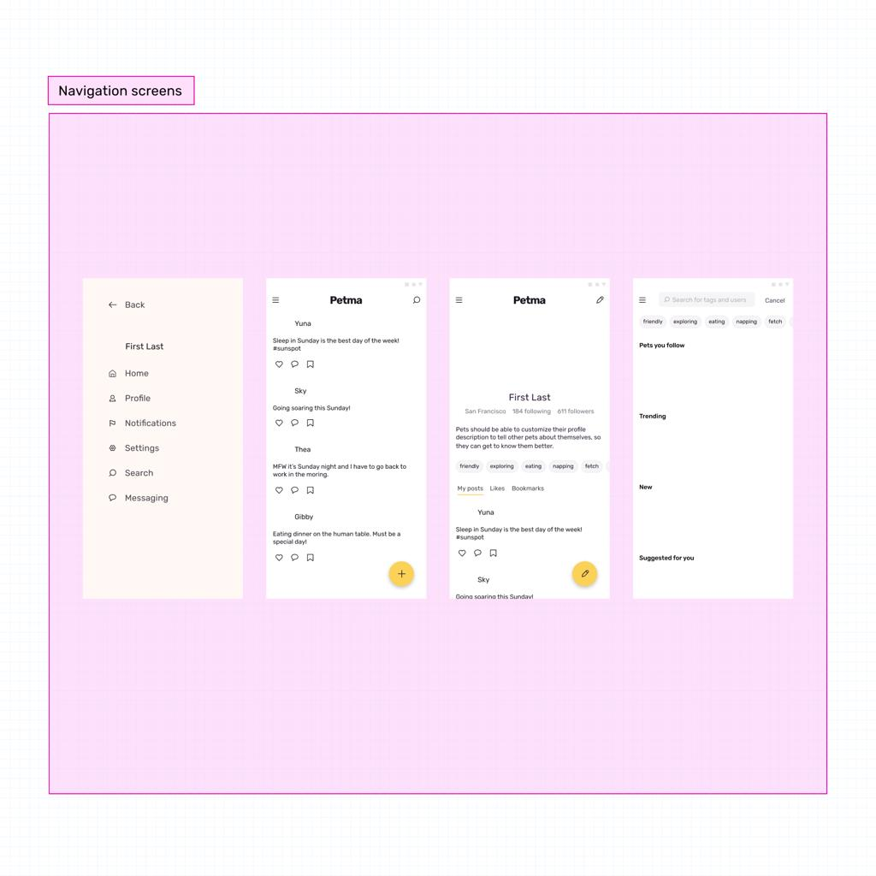

7. Create UI Components
Design reusable:
- Buttons
- Input fields
- Cards
- Tables
- Dropdowns
- Modals

Create Components
Select element →
- Right click →
  - Create Component
Benefits:
- Reusability
- Consistency
- Faster editing

8. Use Auto Layout
Press:
- Shift + A
Auto Layout helps:
- Responsive resizing
- Equal spacing
- Dynamic content
Very important for web apps.

9. Add Typography
Recommended fonts:
- Inter
- Roboto
- SF Pro
- Poppins

Create hierarchy
Example:
- Heading → 32px
- Subheading → 24px
- Body → 16px

10. Choose a Color System
Example:
- Primary color
- Secondary color
- Background color
- Error/warning colors
Use:
- Styles
- Variables
Example dashboard colors:
- Blue
- Purple
- Gray
- White
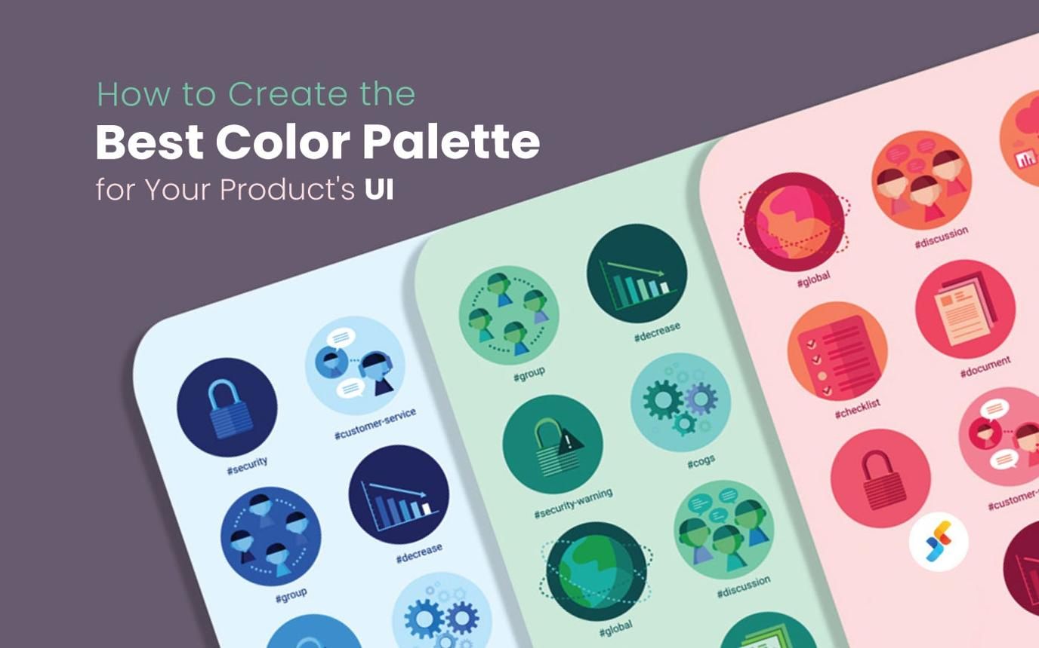
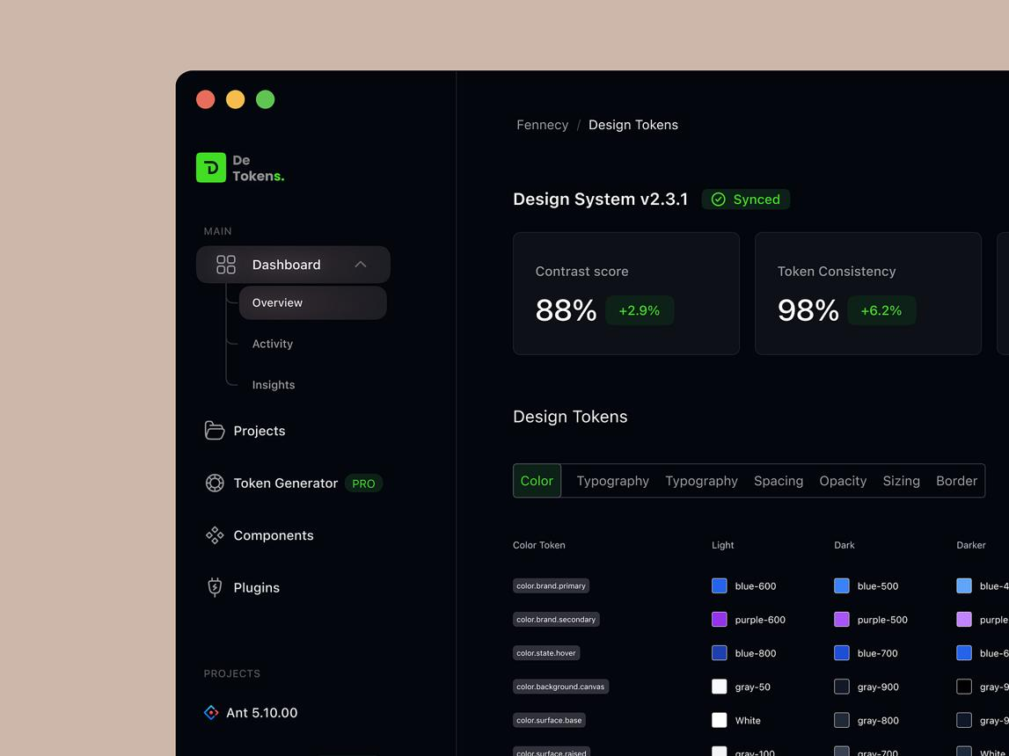
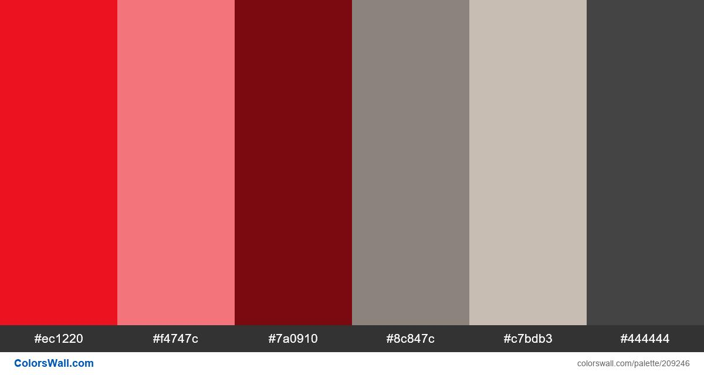

11. Add Images and Icons
Use:
- SVG icons
- Illustrations
- Avatars
Popular icon sources:
- Font Awesome
- Material Icons
- Heroicons
Useful Figma plugins:
- Iconify
- Unsplash
- Blush

12. Design Interactive States
Create:
- Hover effects
- Active buttons
- Disabled states
- Loading states
Use:
- Variants
Example:
- Button / Default
- Button / Hover
- Button / Pressed

13. Prototype the Web App
Open:
- Prototype tab
Create interactions:
- Page navigation
- Dropdown opening
- Modal popups
- Sidebar expansion
Use:
- Smart Animate
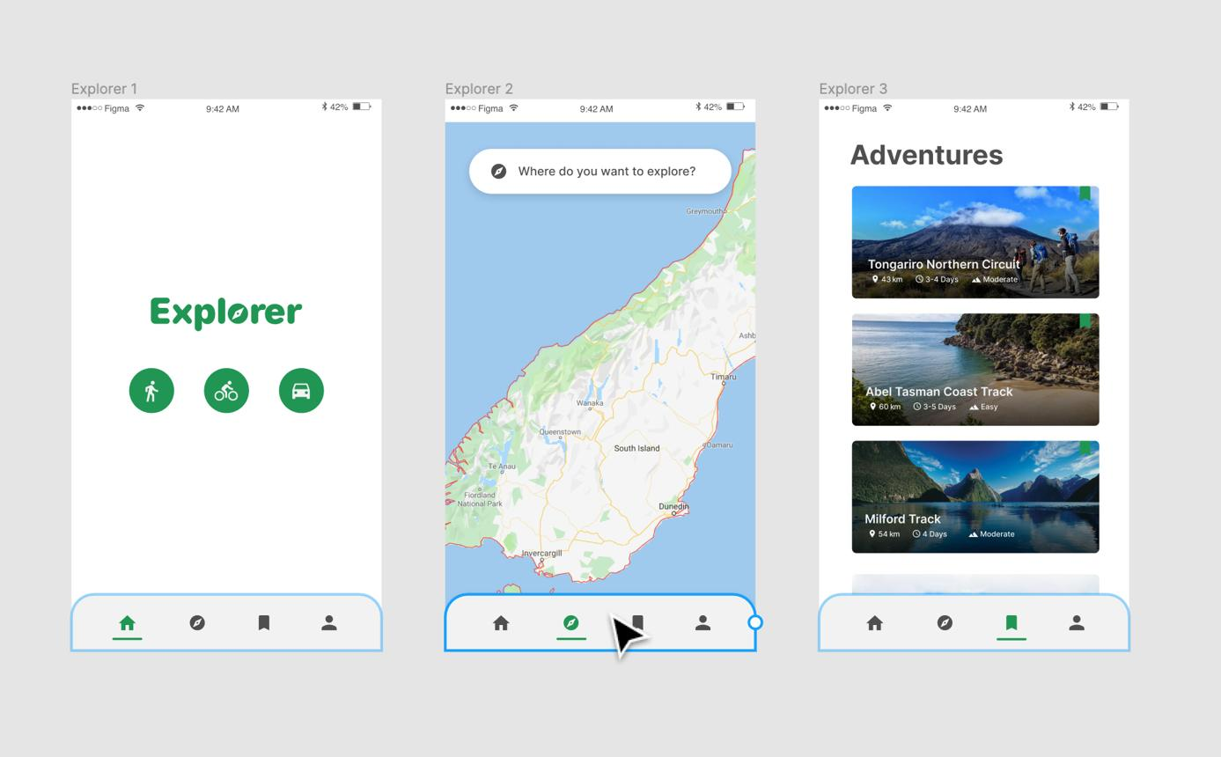
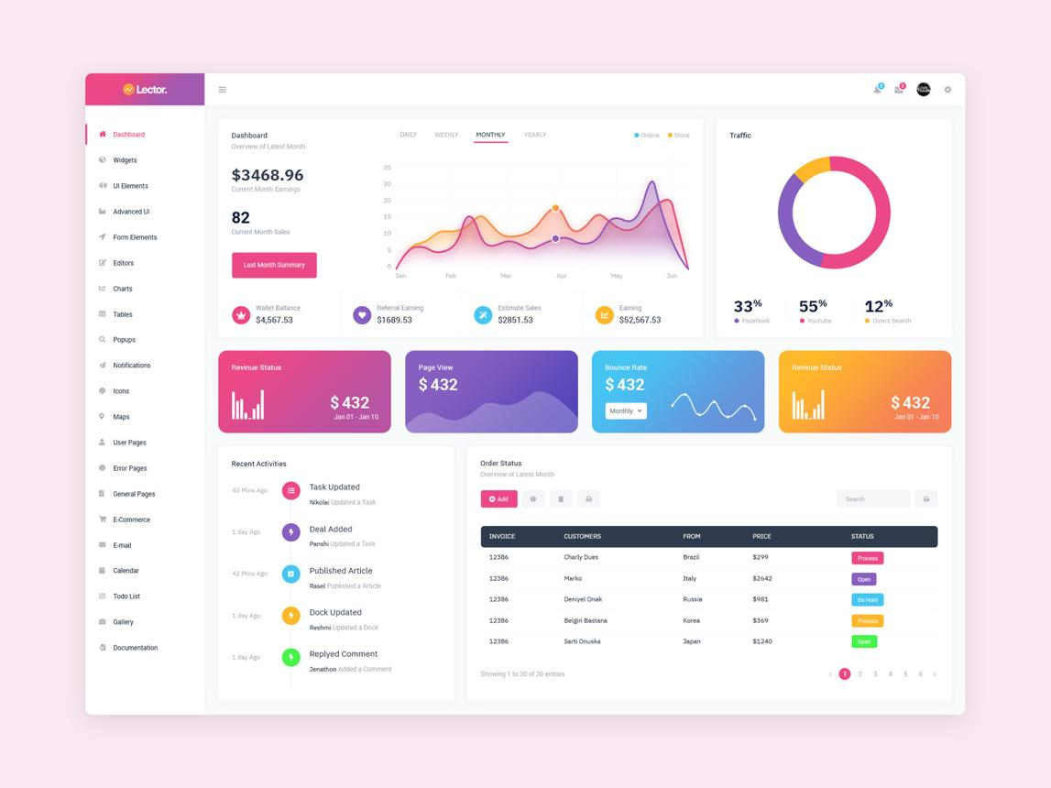
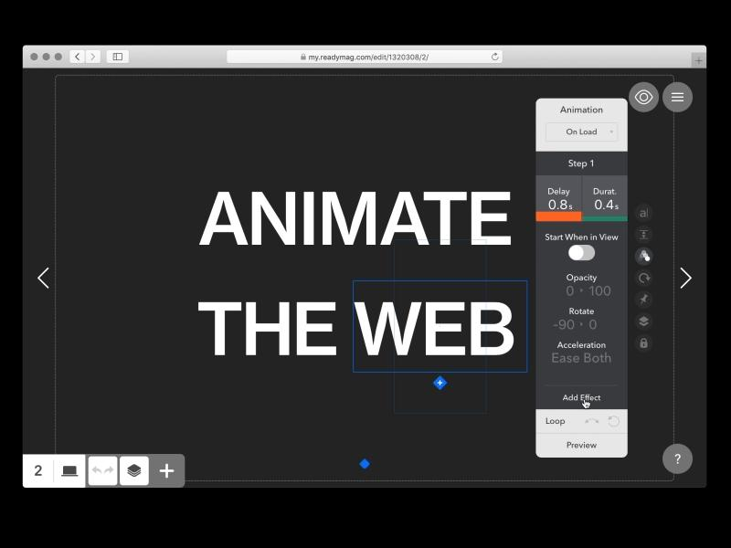

14. Design Responsive Layouts
Create:
- Desktop version
- Tablet version
- Mobile version
Use:
- Constraints
- Auto Layout
Responsive breakpoints:
- Desktop
- Tablet
- Mobile

15. Organize the File
Good structure:
- Pages
- Sections
- Components
- Assets
Example pages:
- Wireframes
- Components
- Final UI
- Prototype

16. Create a Design System
Include:
- Colors
- Typography
- Buttons
- Spacing
- Icons
Benefits:
- Consistency
- Team collaboration
- Faster scaling

17. Share with Developers
Use:
- Inspect panel
- CSS values
- Export assets
Developers can inspect:
- Sizes
- Colors
- Padding
- Fonts

Recommended Beginner Web App Projects

Easy
- Login page
- Portfolio dashboard
- Weather app

Medium
- E-commerce dashboard
- Learning platform
- Chat application

Advanced
- Banking system
- CRM dashboard
- Analytics platform
- Project management tool
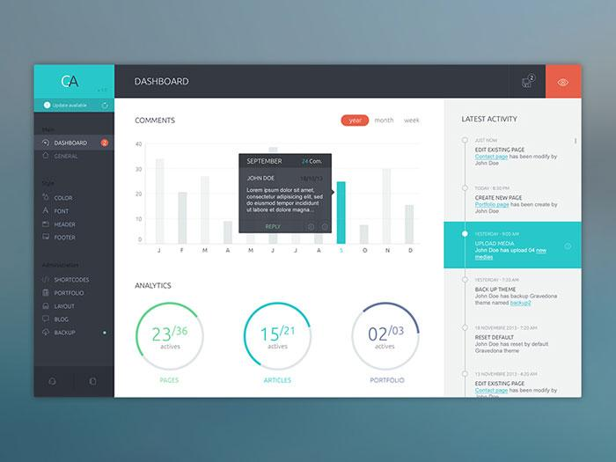


4

Important Figma Features for Web Design
Learn these well:
- Frames
- Auto Layout
- Components
- Variants
- Constraints
- Styles
- Variables
- Prototyping
- Smart Animate
Helpful resources:
- Figma Community
- Figma Learn Design
- Material Design System
- Dribbble UI Inspiration

